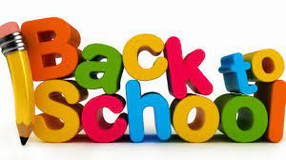

School supplies for this year 2021-22
20$ school fee
Clean indoor running shoes
Clean masks with storage bag/container
Water bottle with student’s name
Lunch bag
Pencil case

